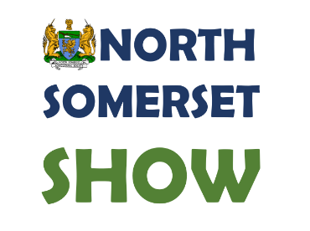

166th North Somerset Show 2026
Sponsorship Form

1) Please complete this form clearly and in BLOCK capitals

2) Completed forms should be returned to: NSAS, ‘Our Offices 4’, Yeowood Farm, Iwood Lane, Wrington, Bristol, BS40 5NU OR forms can be emailed to tim@nsas.org.uk .

Company:

Contact Name:

Company Address:

Telephone number:

Email:

I would like to sponsor ……………………………………… for the sum of £……………

Please tick: ( ) I have enclosed a cheque payable to ‘ North Somerset Agricultural Society’
Or: ( ) Please invoice me.

Name: ……………………………………………… Signed: ………………………………………………
Date:……………………………

Please send a colour .jpg version of your logo and a short commentator announcement to jo@nsas.org.uk

